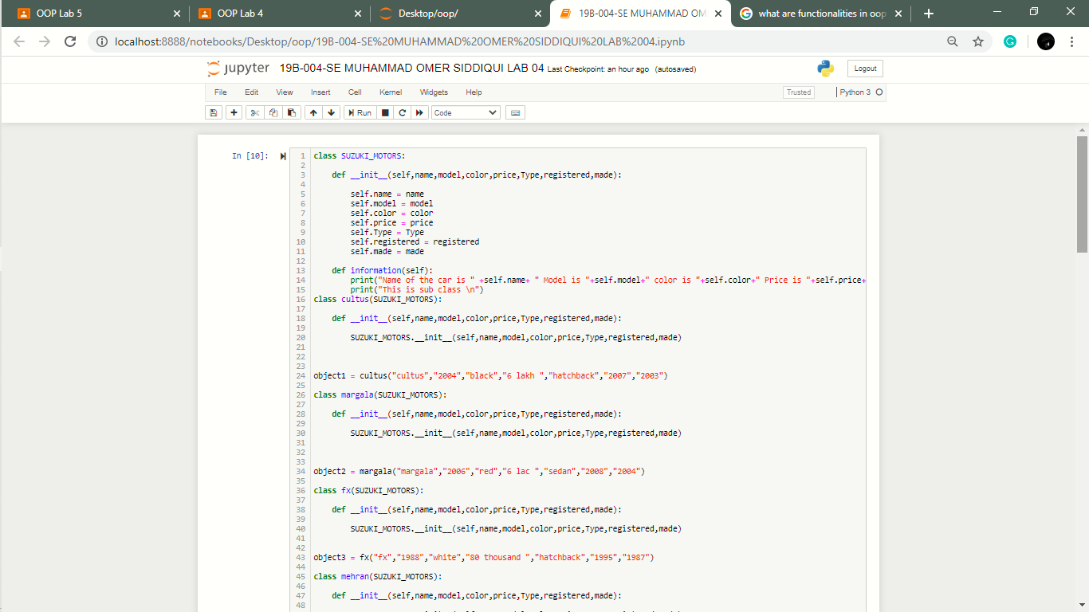

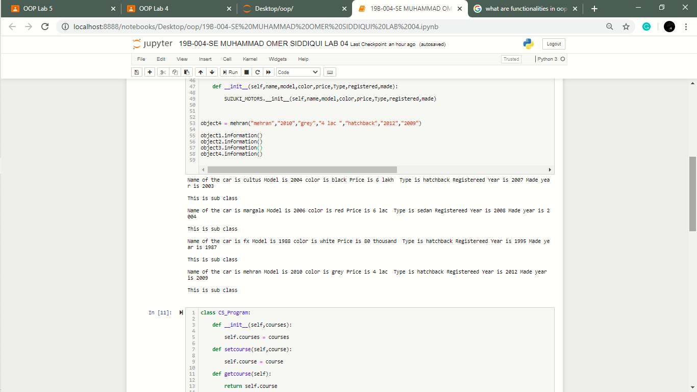

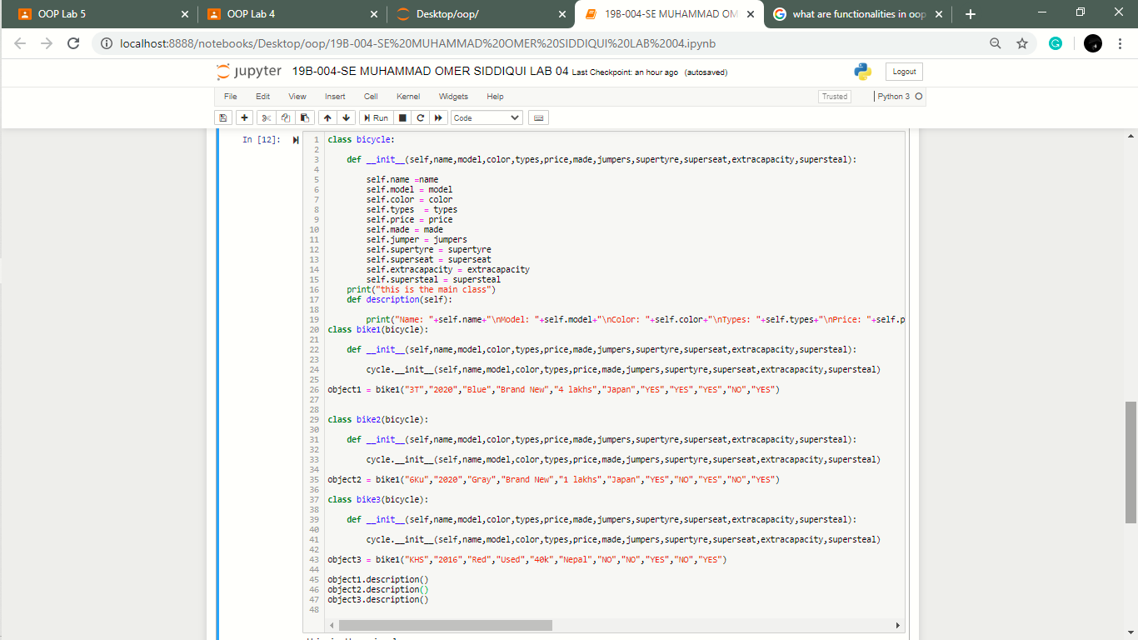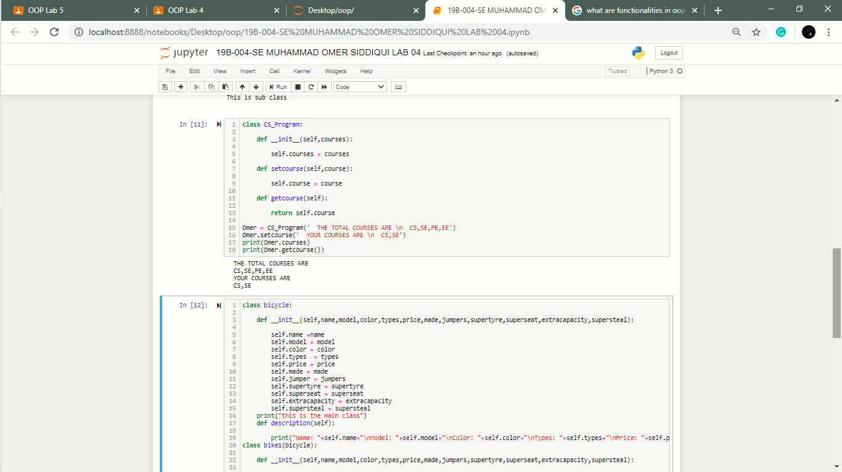

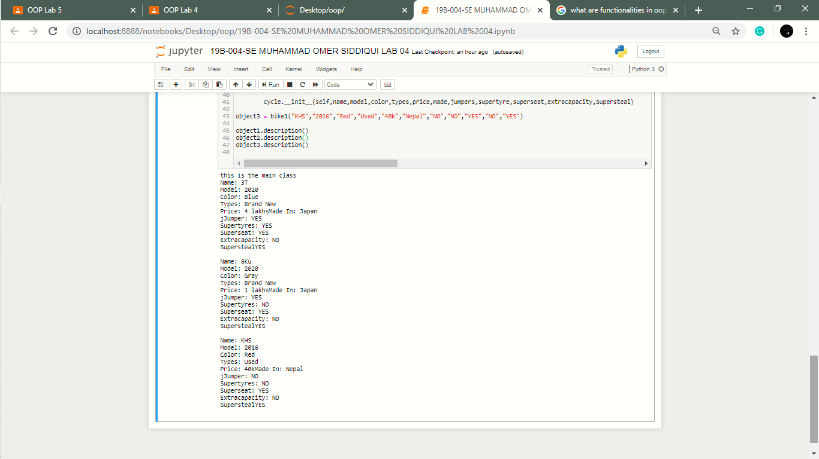

***TASK1:***

**CLASS:**

It is a user-defined data type, which holds its own data members and member functions, which can be accessed and used by creating an instance of that **class.**

**OBJECT:**An **object, in object-oriented programming** (**OOP**), is an abstract data type created by a developer. It can include multiple properties and methods and may even contain other **objects**.

**CHARACTERSTICS:**

Some basic **features** for **Oop** are: Encapsulation of data (getters and setters) Class data. Polymorphism (very important) = property of an object to take another object properties (includes overloading and overriding methods) Inheritance.